Съкратен синаксис на if statement

function solve(num1, num2, num3) {

    let res = num1 + num2 + num3

res % 1 === 0 ? res += ' - Integer': res += ' - Float'

    res % 1 === 0 ? res += ' - Integer': res += ' - Float'

    console.log(res) ако това е вярно върни това ако не върни това

}

Math Library

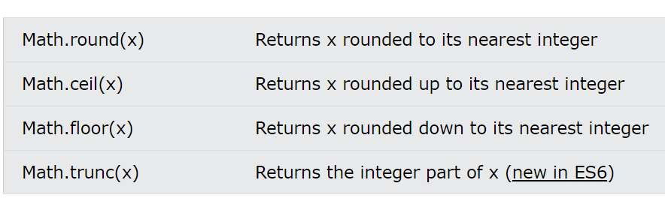

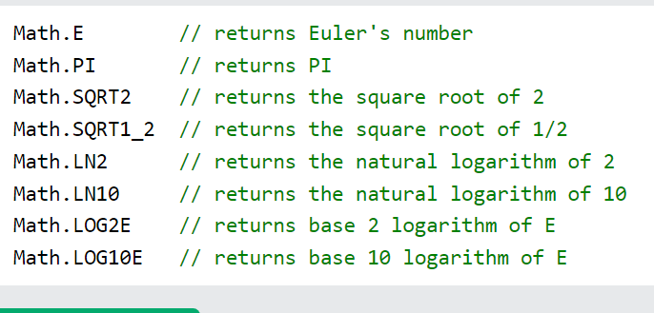

Array elements

let numbers = [1, 2, 3, 4, 5, 6, 7, 8, 9, 10]

let firstElement = numbers[0]

let lastElement = numbers[numbers.length - 1]

// destructuring of elements

let nums = [1, 2, 3]

let [first, second , third] = nums

console.log(`first = ${first} , second = ${second} , third = ${third}`)

output:

first = 1 , second = 2 , third = 3

operator . . . unpack

let nestedArrey = [1, 2, 3, ... [4, 5, 6]]

output:

[1, 2, 3, 4, 5, 6]

console.table(nestedArrey)

┌─────────┬────────┐

│ (index) │ Values │

├─────────┼────────┤ printing like table

│    0    │   1    │

│    1    │   2    │

│    2    │   3    │

│    3    │   4    │

│    4    │   5    │

│    5    │   6    │

└─────────┴────────┘

Array methods

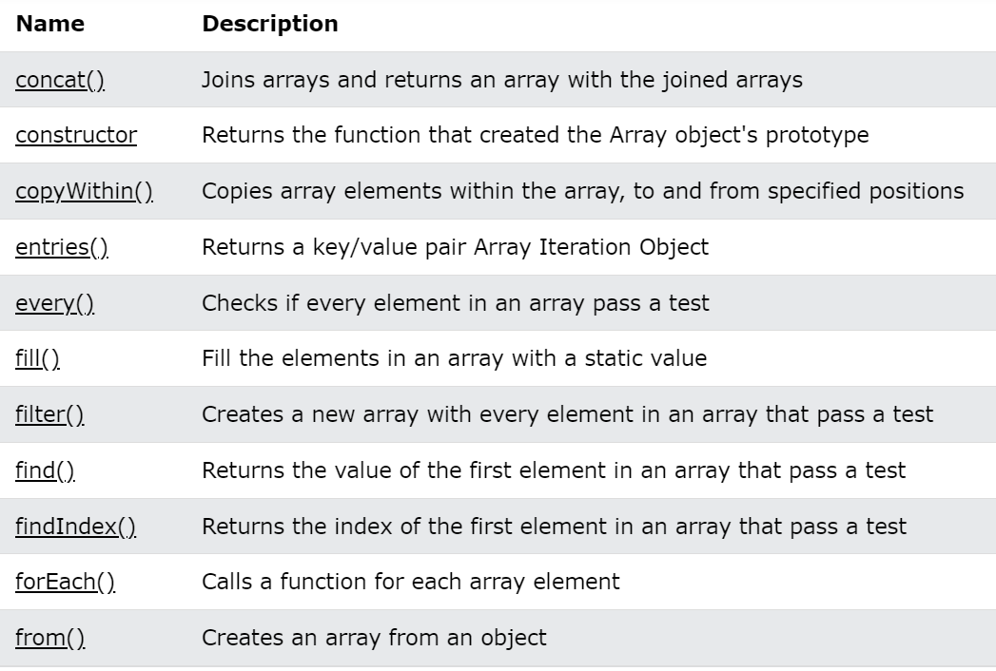

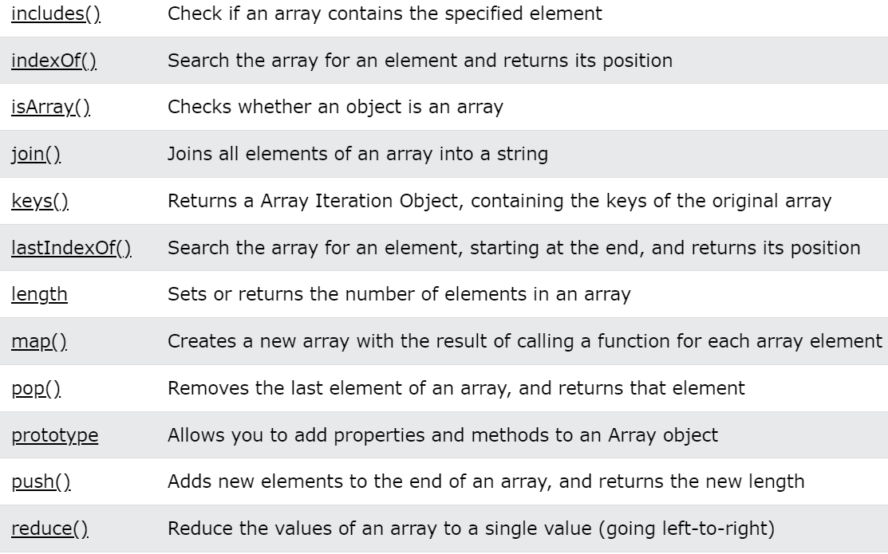

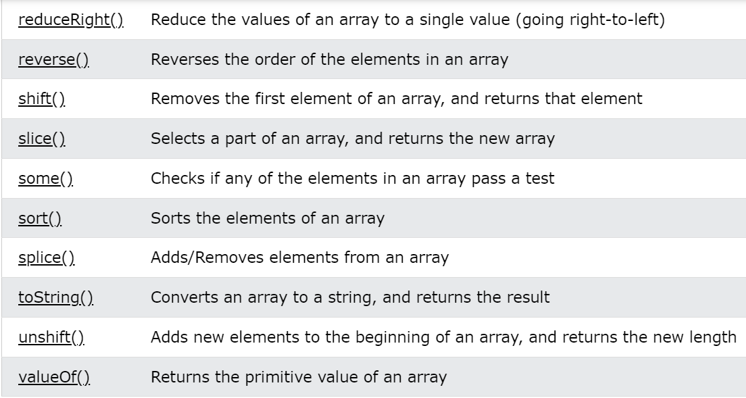

Sum all elements in array, check all element in array is the same

function solve(num) {

    let array1 = num.toString().split('')

    const isTrue = array1.every(x => x === array1[0]) this is like all() in Python

    // const initialValue = 0;

    let sum  = array1.reduce((x,y) => Number(x) + Number(y) //, initialValue )

    console.log(isTrue) this is like sum() in Python

    console.log(sum)

}

solve(2222222)

solve(1234)

Array sort methods

let number = [31, 2 , 432, 32, 5 , -1]

let names = ['Kiro', 'Pesho', 'Ivan', 'Sasho']

// ascending sort number

let sortedAscNum = [...number].sort((a, b) => a - b)

console.log(sortedAscNum)

// descending sort number

let sortedDescNum = [...number].sort((a, b) => b - a)

console.log(sortedDescNum)

// ascending sort string

let sortedAscStr = [...names].sort((a, b) => a.localeCompare(b))

console.log(sortedAscStr)

// descending sort string

let sortedDescStr = [...names].sort((a, b) => b.localeCompare(a))

console.log(sortedDescStr)

output :

[-1, 2, 5, 31, 32, 432]

[432, 32, 31, 5, 2, -1]

['ivan', 'Kiro', 'Pesho', 'Sasho']

['Sasho', 'Pesho', 'Kiro', 'ivan']

string methods

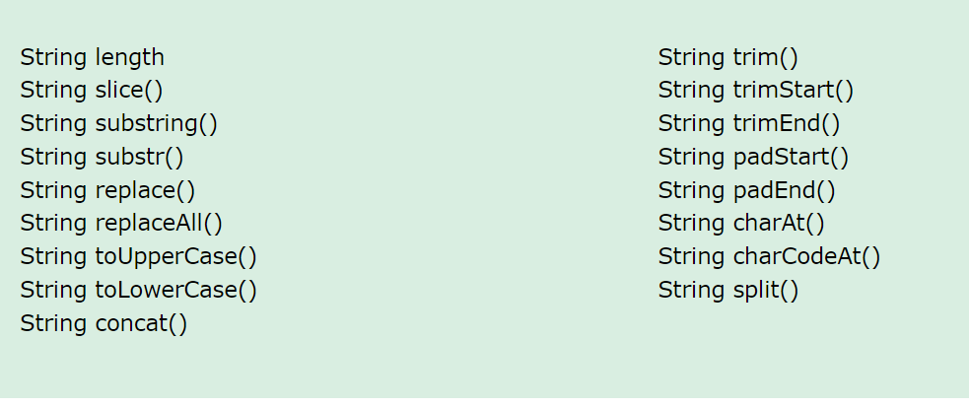

Char in ascii table

function solve(char1, char2) {

   let start = char1.charCodeAt(0) от символ към цифра

   let end = char2.charCodeAt(0)

   let character = []

   for (let index = start + 1; index < end; index++) {

        character.push(String.fromCharCode(index)) от цифра към символ

   }

   return character.join(' ')

}

console.log(solve('#',':'))

make unique array

function solve(arr) {

    let uniqueArr = arr.filter(function (element, index, self) {

        return self.indexOf(element) === index;

    });

    console.log(uniqueArr.join());

}

solve([7, 8, 9, 7, 2, 3, 4, 1, 2])

output : 7 8 9 2 3 4 1